How to connect and log on to Azure servers.

RDP is not allowed from on premise to some of the servers in Azure. RDP is allowed to RDS servers obviously.

To connect to the other servers, like the DC’s, you need to log onto Azure.

Then find the VM you want to get onto. You can filter by subscription and resource group.

Click connect > bastion.

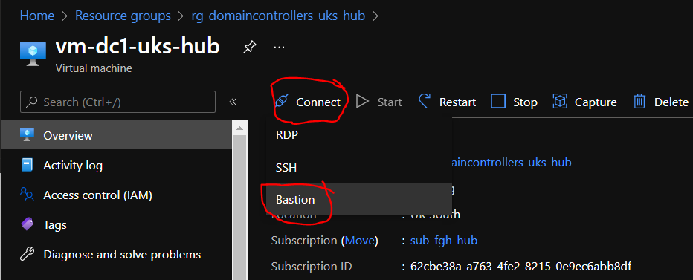

Then enter your credentials and connect.

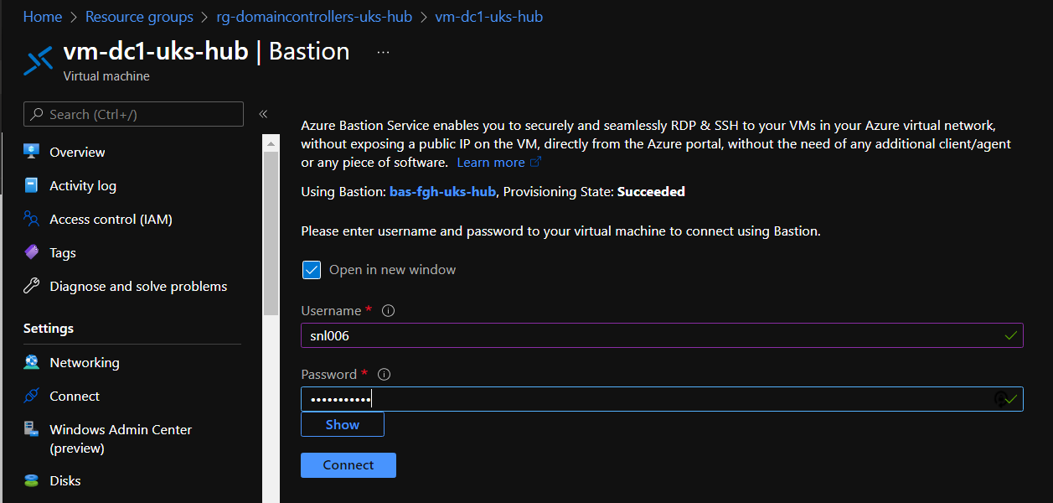

It will open an RDP web page.